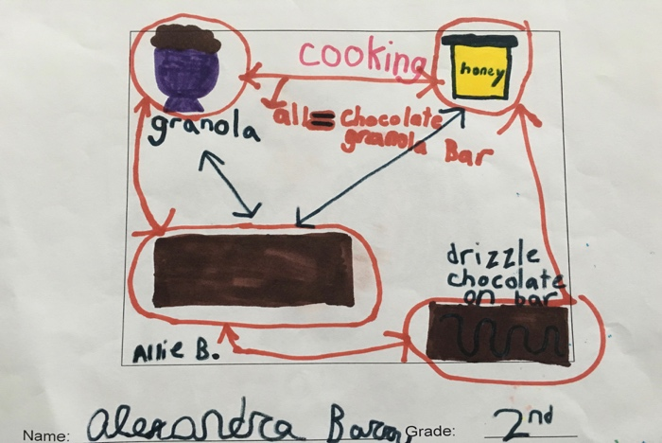
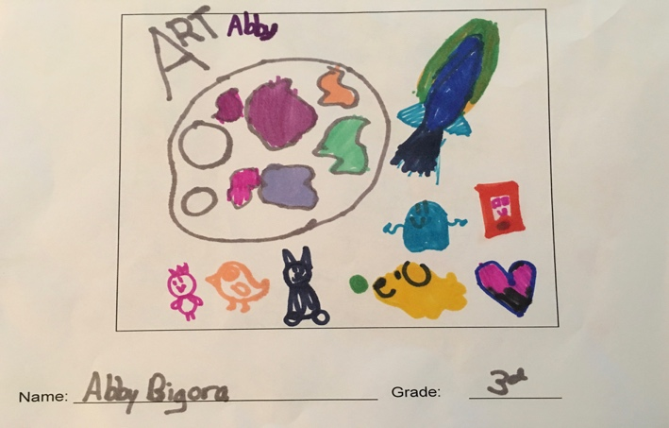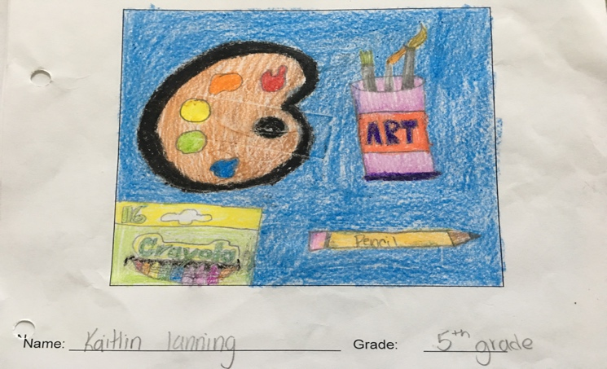

PTO ENRICHMENT
2017

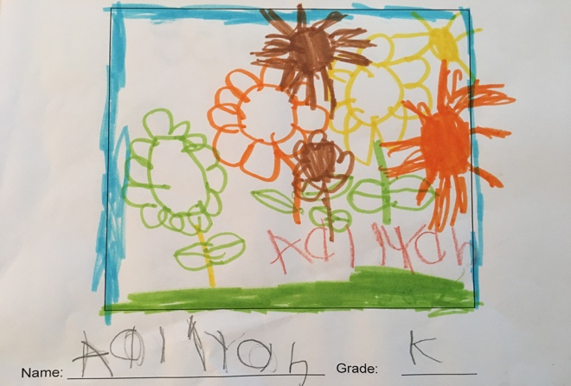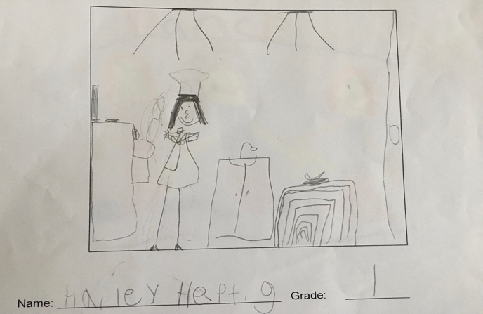
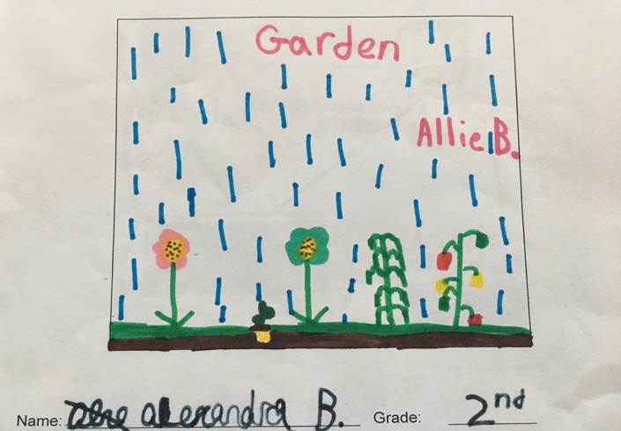

The Remsenburg‐ Speonk PTO Enrichment Committee is pleased to offer the following after school Enrichment classes. Our program is created and runs completely by parent volunteers and support from the school staff. Please contact one of the committee members if you would like to volunteer.

IMPORTANT DATES

- PTO Enrichment Registration is on Wednesday, November 16, from 5:30 – 6:15.
- PTO Enrichment is a 5-week program, running from January 9 to February 10, 2017.
- The classes run Monday, Tuesday, Thursday and Friday from 3:30 to 4:45pm.
- There will be no classes on Monday, January16th, due to Martin Luther King Jr. Day.

REGISTRATION INFORMATION

Registration is first come, first served, and payment is due at this time. Please have your form filled out prior to arrival at the signup night during the Holiday Story Night held on Wednesday, November 16 from 5:30 to 6:15.

DURING THE PTO ENRICHMENT PROGRAM

- If your child cannot attend his/her PTO Enrichment class, and goes to school that day, please send a note to their teacher excusing them from PTO Enrichment. If you don’t provide a note, they will be brought to PTO Enrichment--not their bus.

- Please provide your child with an after school snack.

- PTO Enrichment is for Remsenburg-Speonk Elementary Students only.

- Pick up is promptly at 4:45 p.m.; please pick up in the front of the school. If your child is going home with someone other than listed on the Registration Form, a note is necessary.

- If a parent or guardian is continually late picking up their child, or if there are behavior problems with your child, the child will be dropped from the program. No refund will be issued.

- PTO Enrichment will follow school closings and early dismissals during inclement weather.
Make up classes will be arranged, and you will be notified.

If you have any questions, please contact Amy Barry at amybarry@gmail.com, Lauren Czerwinski at nyccabgirl@gmail.com or Jennifer Haley at mysticalflute@gmail.com.

Thank you for your cooperation and support!

The Enrichment Committee
MONDAYS

January 9, 23, 30; February 6
CREATIVE COMPUTING WITH SCRATCH

Teacher: Phil Smyth/Steven Pomroy
Grades 4-6
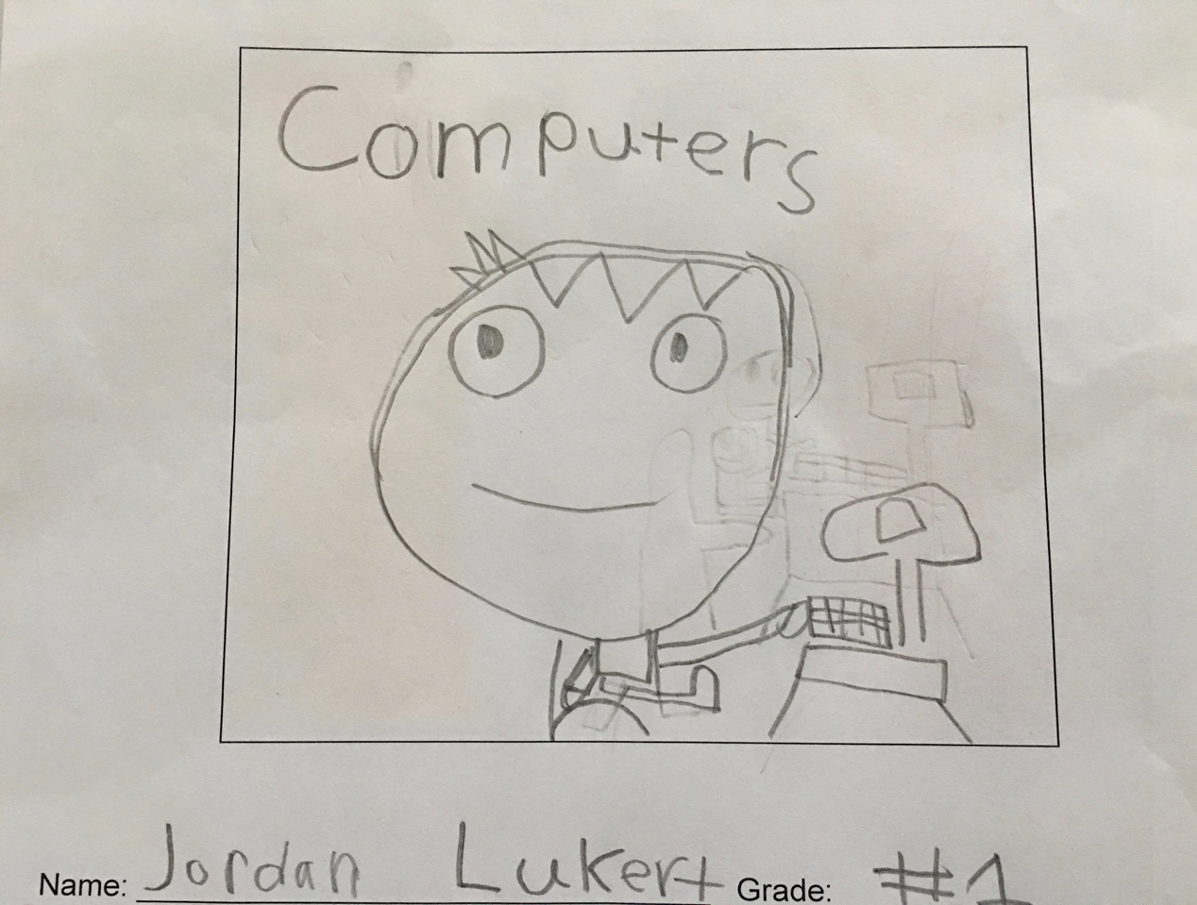

Learn how to tell computer what to do with code. Create games, animations, and even get it to do your math homework! Scratch is easy and fun. Just put the pieces together and watch your creation go. You will be guided through a project or be helped with your own ideas. Team up with a friend to build your masterpiece. Fun for beginners or experts!

CAN YOU DIG IT?

Teacher: Suzann Henninger
Grades: K-3

Did you know that RSE is building a school garden? This class is the beginning of our growing the school garden. Each week your child will make a garden inspired craft. Decorate and plant an organic herb planter! Paint river rocks and make a sprout house from sponges and seeds! Learn about bees and why they are so important. A special visit from our master gardener will teach us about earthworms!

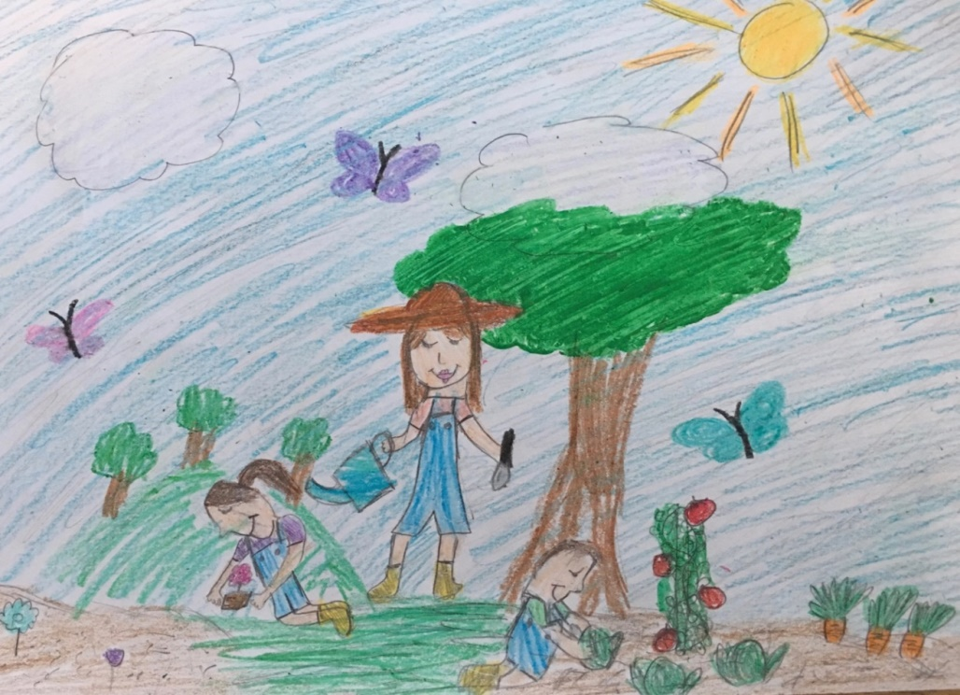

By Lilah Caputo

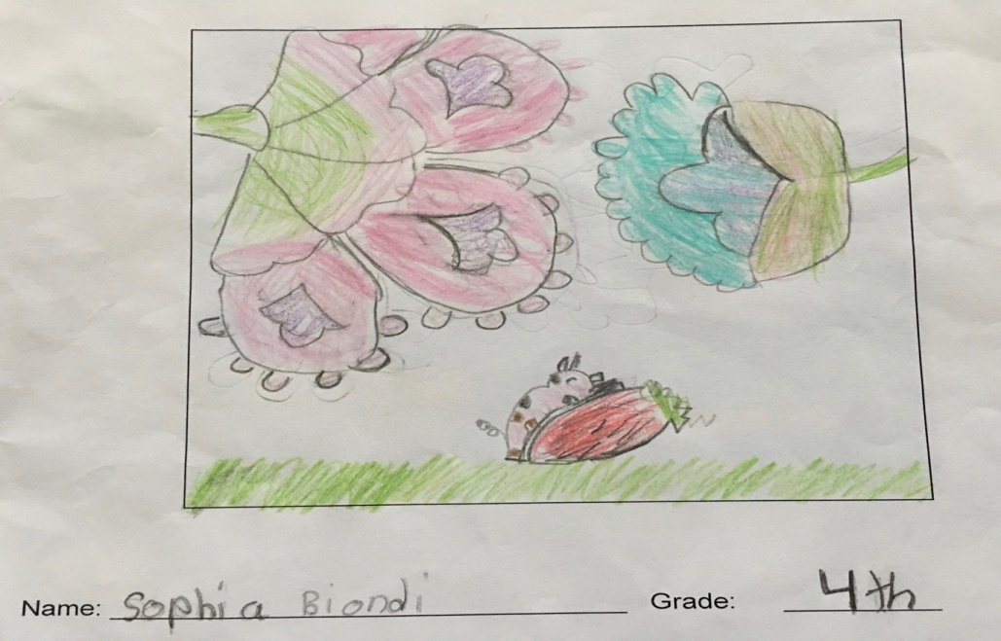

ART: CLAY PLAY

Teacher: Mr. Massey Grades 2-4

Come sculpt with Mr. Massey! Students will be given the opportunity to create projects using a variety of clay and claylike materials. Channel your inner Michelangelo!

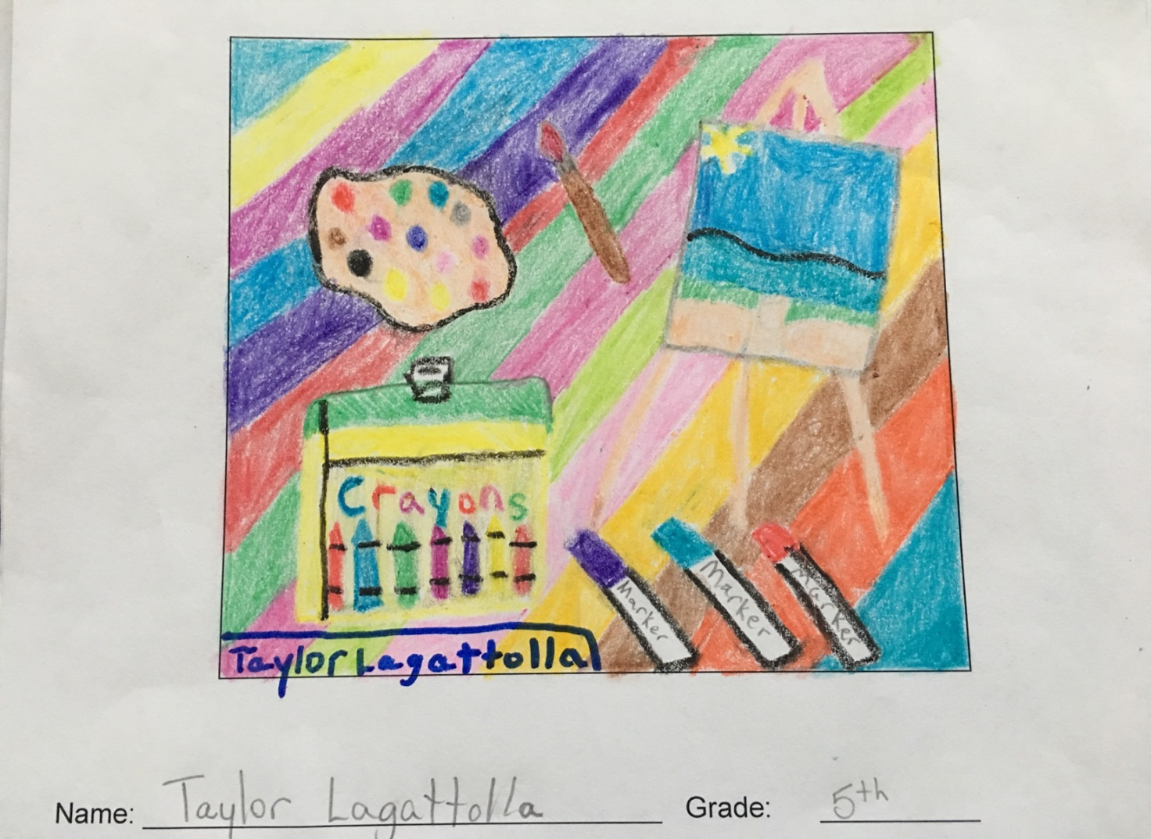

TUESDAYS

January 10, 17, 24, 31; February 7

MAD SCIENTISTS
Teacher: Steve Biasetti
Grades: 5-6

Get ready to unleash your inner mad scientist! In this class we dabble in all sorts of safe, age appropriate experiments demonstrating chemical and physical changes, density, chromatography, etc. Make elephant toothpaste, alka-seltzer rockets, milk rainbows, slime and ice cream! Bring your curiosity and your lab coat!

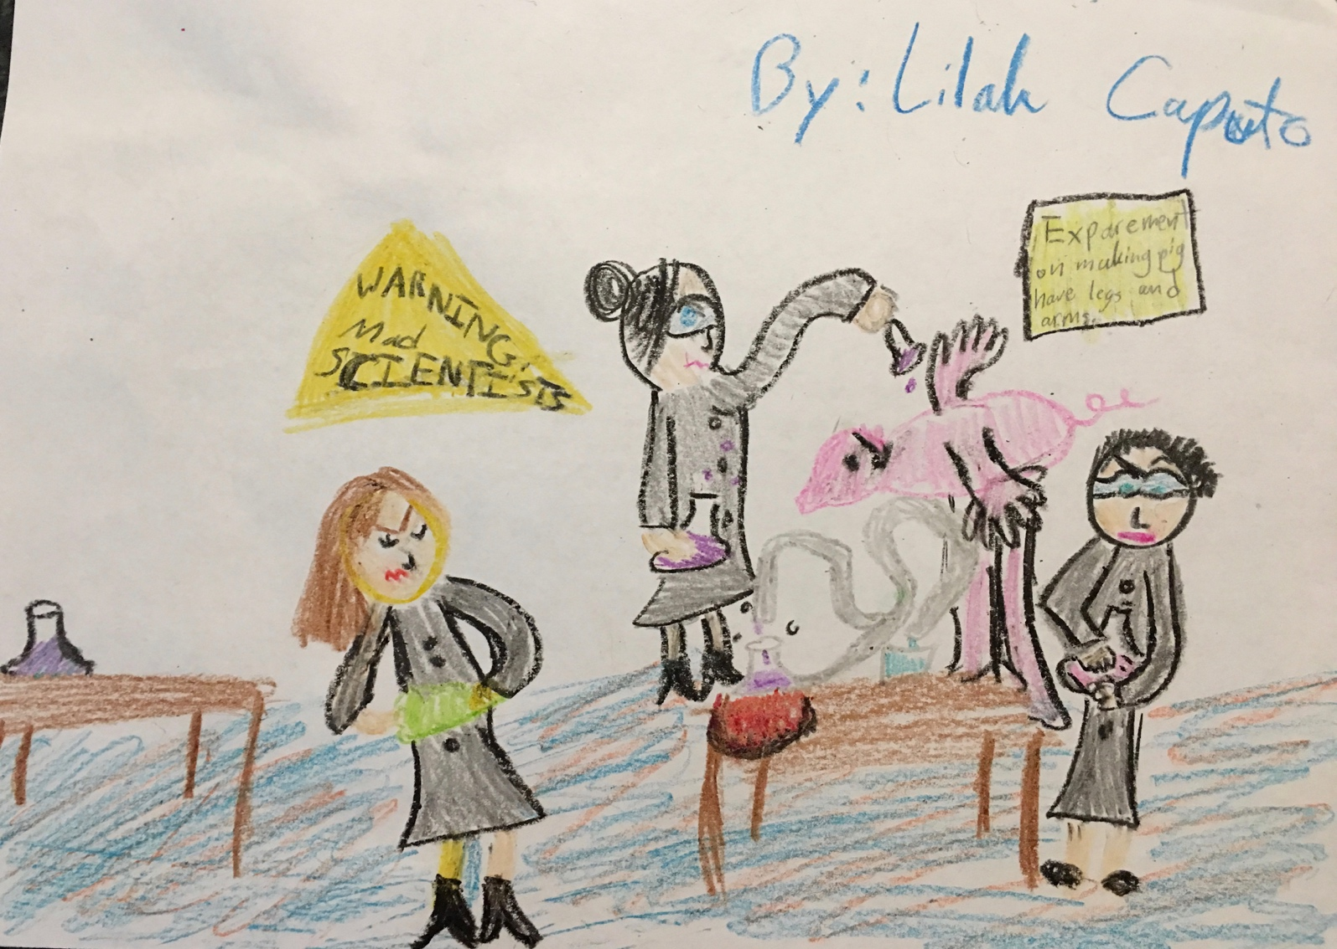

MULTI-SPORT
Teacher: Scott Heptig
Grades K-3

Get ready, get set, go!! Each week is a fun game involving “hands on play.” Your child will get to know his classmates as well as a few other grades!

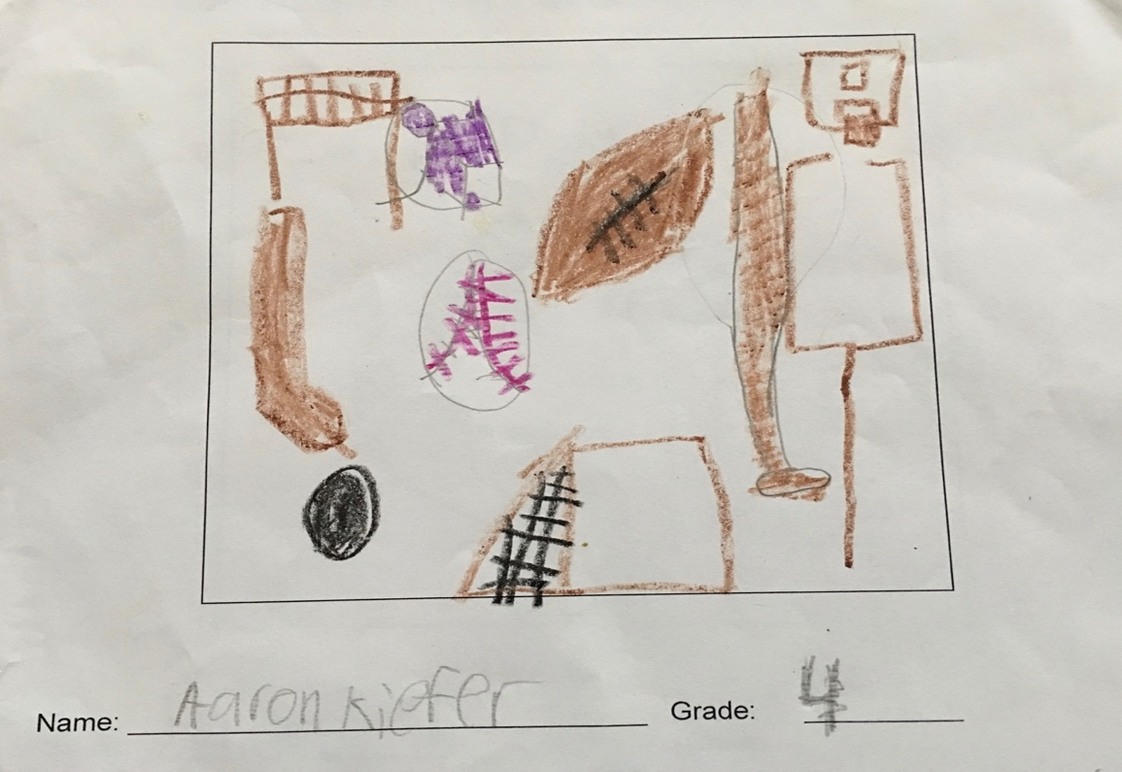

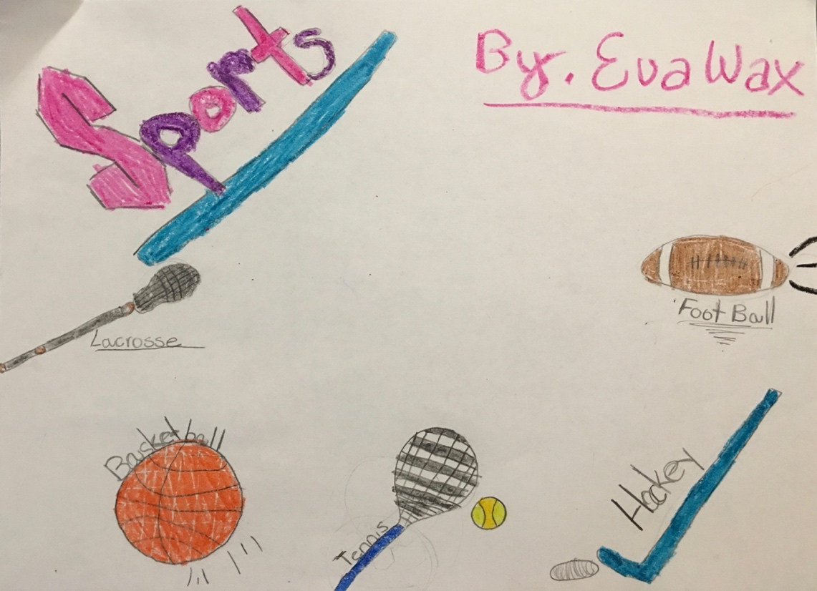

NO BAKE COOKING CLASS

Teacher: Lauren Czerwinski
Grades 2-6

Join us for a hand’s on cooking class. Obtain a healthy and happy connection to food. Learn basic cooking skills, how to read a food label, measurements, and more. Every week we will “cook” at least one recipe item. Each child will create their own recipe book through the weeks and will be able to take it home with them at the end. The menu will be emailed to participating families prior to the start of class. Some menu ideas could be: banana bites with homemade granola, smoothies, non bake cookies, veggie sushi.

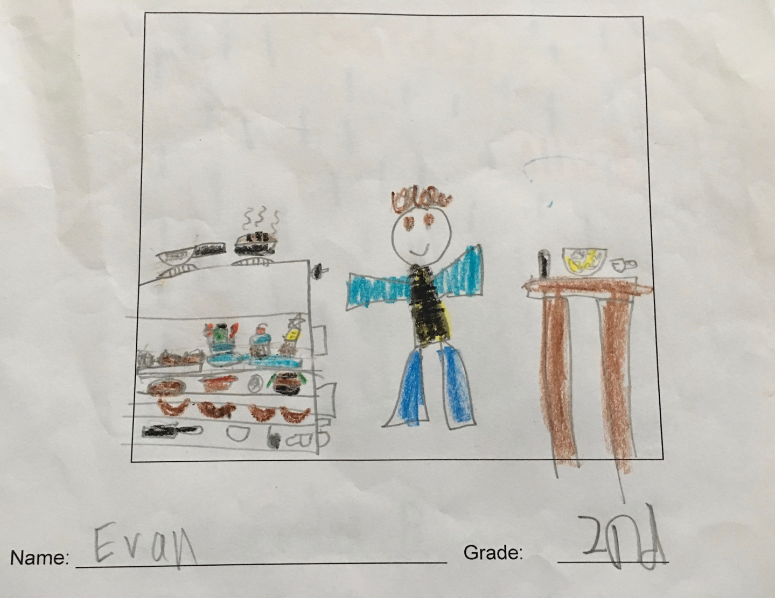

BEADS AND JEWELRY
Teacher: Marjorie Oxman Grades 2-6

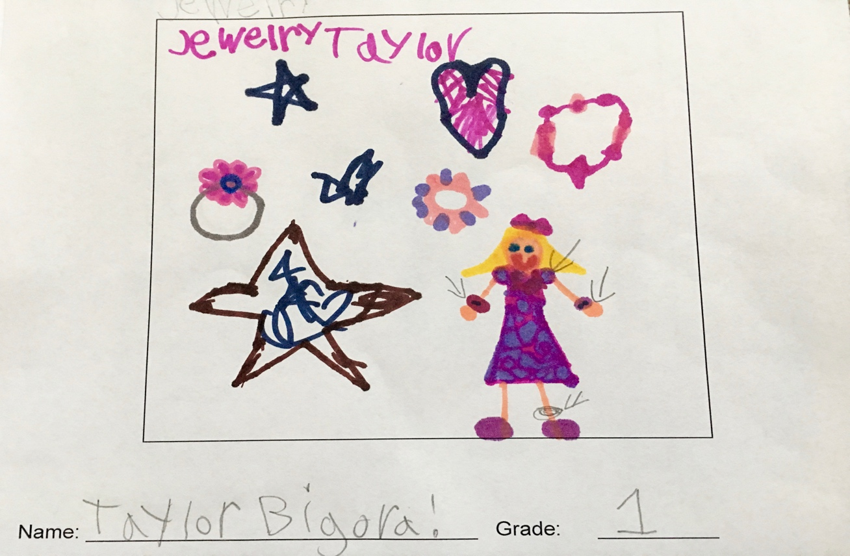

Colorful necklaces, shiny bracelets, beautiful rings! In this class, you can let your creative side shine through while having fun with friends and creating something unique!! Lovely gifts for friends and family … but do keep some for yourself!!

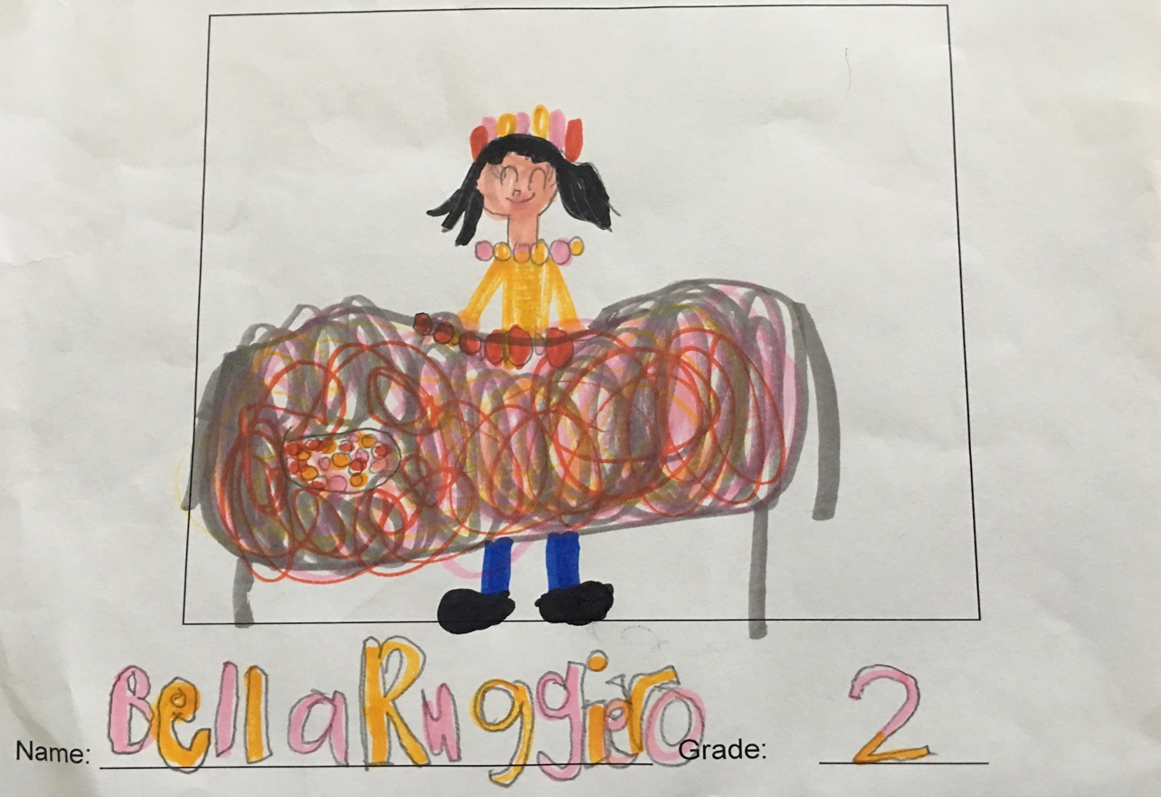
THURSDAYS

January 12, 19, 26; February 2, 9

MAD SCIENTISTS

Teacher: Steve Biasetti
Grades 3-4

New this year! Get ready to unleash your inner mad scientist! In this class we dabble in all sorts of safe, age appropriate experiments demonstrating chemical and physical changes, density, chromatography, etc. Make elephant toothpaste, alka-seltzer rockets, milk rainbows, slime and ice cream! Bring your curiosity and your lab coat!
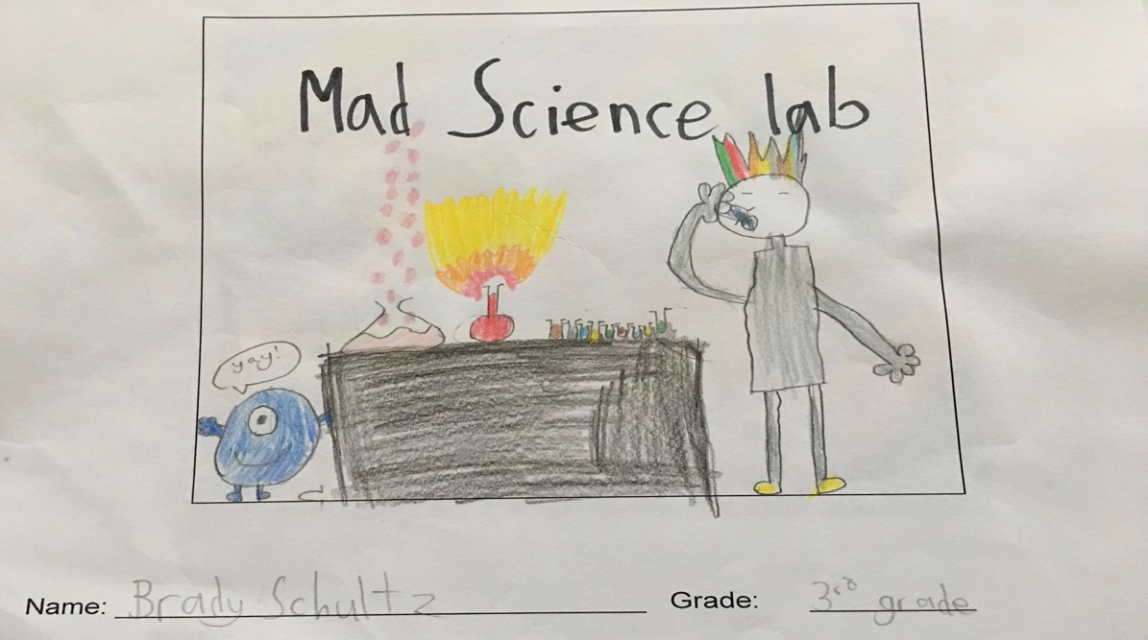

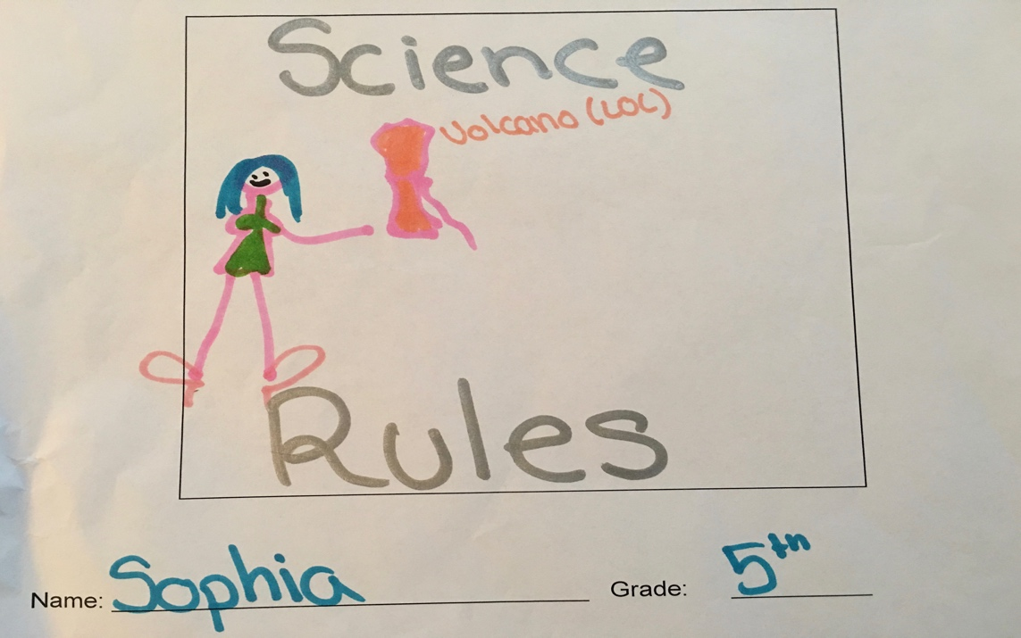

KNITTING

Teacher: Florence Lampasona Grades 4-6

Learn knitting basics or improve on your knowledge. This class is great for chatting and learning a hobby that will stay with you for a lifetime!

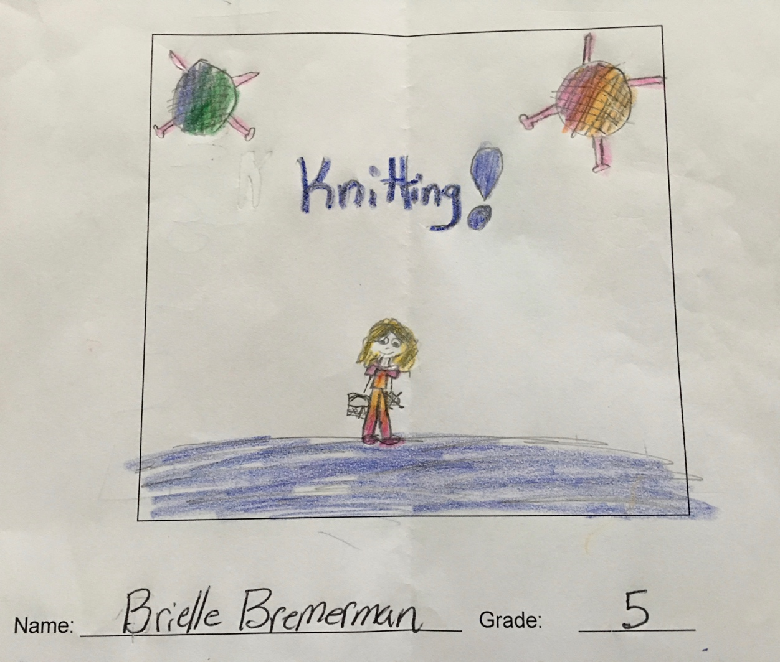

Young Crafters!

Teacher: Jen Bigora Grades K-3

Get your craft on! This is the longest running PTO Enrichment class for good reason. Create a fun craft each week and play a game with friends! It’s just pure fun for your young child. Let their imagination of play run wild!

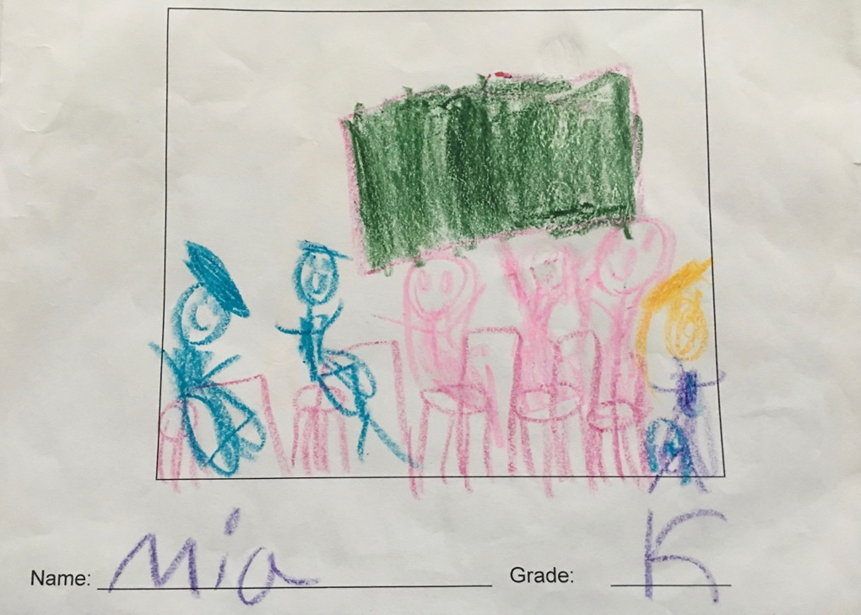

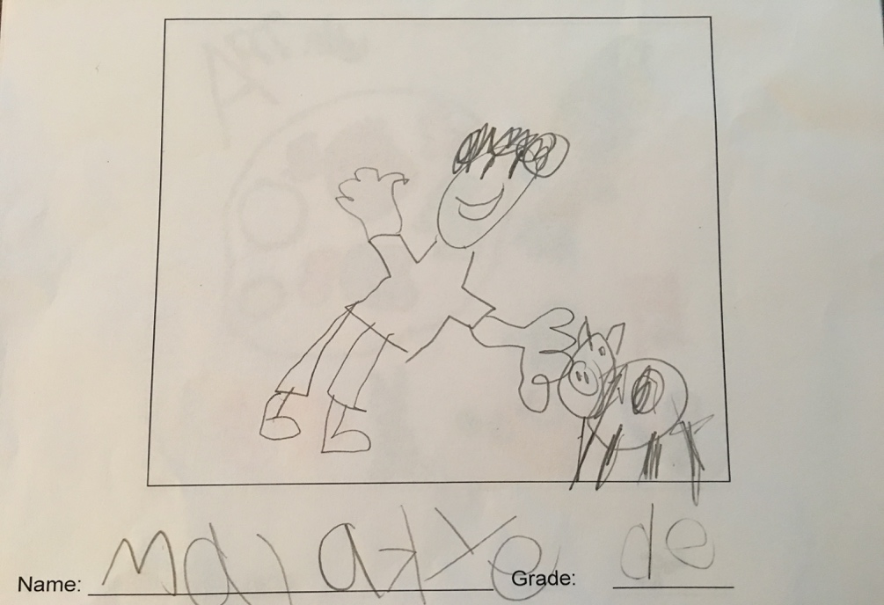
FRIDAYS

January 13, 20, 27; February 3, 10

KICKBALL

Teacher: Artie Haley Grades 4-6

It’s still winter, but you can come play some ball inside in a fun and safe setting!

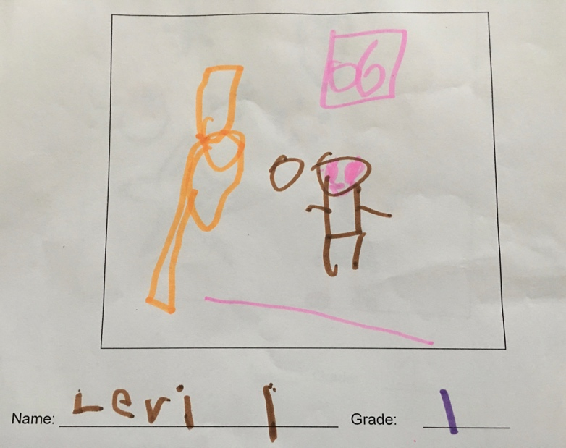

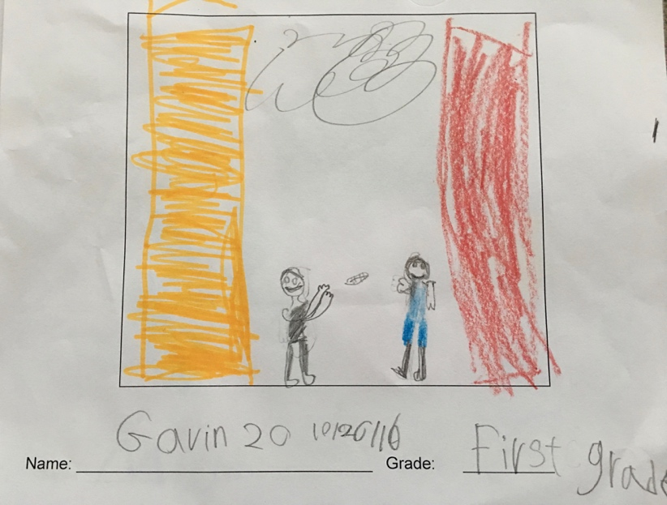

LEGOS

Teacher: Rachel Ferrante Grades K-6

Who doesn’t like to create new worlds, animals or maybe just some thingamajigs with colorful Legos? This class will enable your child’s imagination to take flight while playing with peers and creating whatever their minds fancy. A great way to interact with fellow class mates and other grades close to your child’s age.

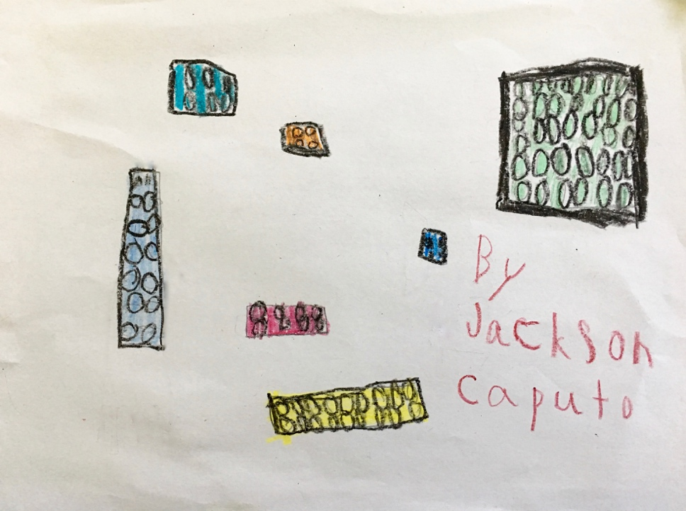

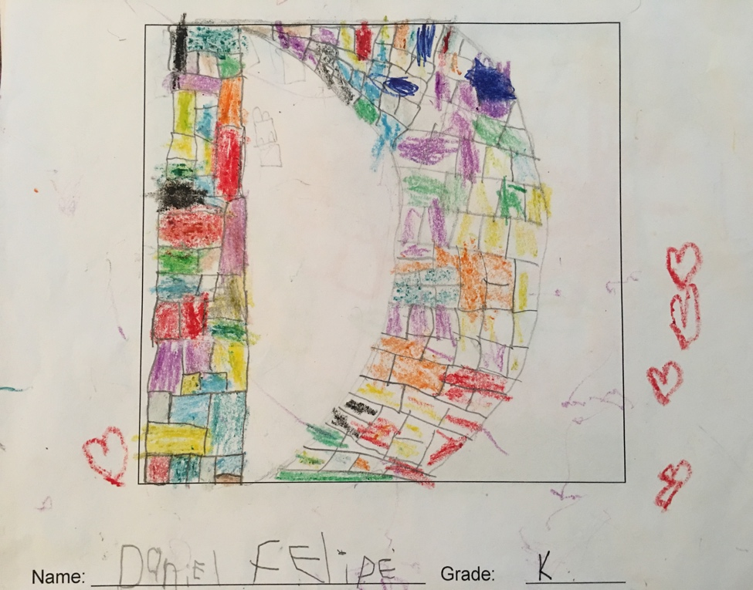

INTRO TO JAZZ DANCE

Teacher: TBD Grades K-3
Learn the basics of jazz dance with Ms. from Dance Centre of the Hamptons and Manorville. Students will stretch, turn and leap across the floor, and learn age appropriate choreography, in a traditional jazz class setting.

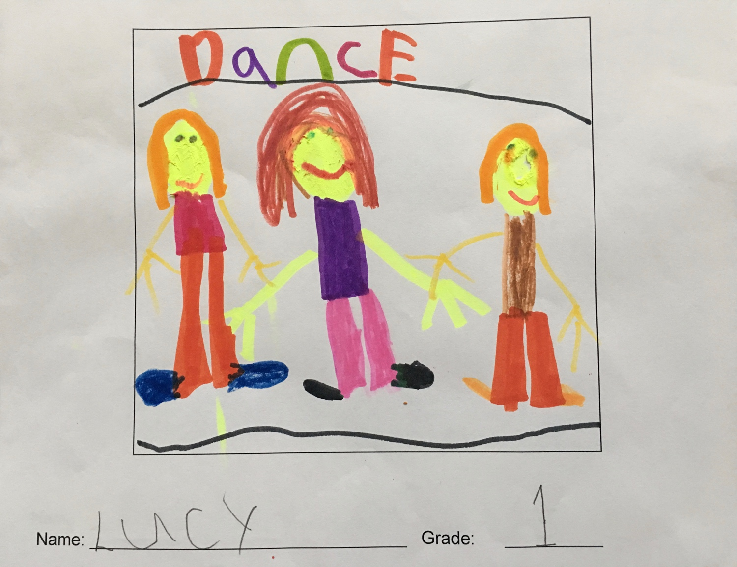

WEAVING
Teacher: Mary Greiner Grades 4-6

A centuries old tradition and can be both practical and beautiful. Learn the basics of loom weaving and skills necessary to create a variety of projects.

